Information Retrieval & Text Mining

Project Update

Student: Glauco Lorenzut

Introduction
I am working on an information retrieval of the literature of H.P. Lovecraft.
Lovecraft was a very active writer of the early 1900s and father of a new genre called cosmic horror. He wrote a good number of long and short fictions that profoundly influenced the other authors of his era. This led to the emergence of a pantheon of vicious cosmic gods that also nowadays influences modern authors.
Ever since I approached his works, I have always found it intriguing to discover the links between the various stories. So, my project regards the information mining of the most recurring characters and entities to highlight the links between Lovecraft fictions.

Corpus
I copied from an official site the complete fictions collection of the author (64 books) and I saved in format docx.
I wanted to avoid introducing other works of Lovecraftian cosmology (collaborations with other writers or works not by the author) because, although they may make a greater contribution to the description of this narrative universe, these new contributions can often be discordant or confusing. Lovecraft is not famous for the clarity of concepts and descriptions (his plots are wrapped in an aura of mystery and dreamlike), therefore adding more material could increase the noise of the concepts to be extrapolated.

Development
I created a script on Python that extrapolates the author's texts and sorts them in the timeline. As a first step I divided each fiction into paragraphs and sentences. For each sentence I performed the tokenization, the analysis of tokens frequency and the extrapolation of bigrams and trigrams with NLTK library.
Given the initial weight of the time (more than 10 minutes) I decided to save the entire book_list object as a binary file to subsequently avoid the previous step. After subsequent improvements, the pre-processing of all books collapsed to just 6-7 seconds.
Analyzing with WordCloud the raw text of the books examined (with some small adjustment of the stopwords) and printing the 30 most frequent words, the following result came out:

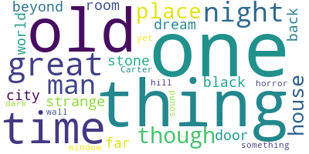

Already with this simple analysis, key concepts of Lovecraftian literature came out: they are almost all words belonging to the horror genre and it is interesting to note how the prevalent subjects of Lovecraftian cosmology, the Great Ones and the Old Ones, came out. In addition, the name of Randolph Carter, a recurring figure within these works, has also come out.

References
- Bibliography and dates:
https://en.wikipedia.org/wiki/H._P._Lovecraft_bibliography

- Corpus site:
http://www.hplovecraft.com/writings/texts/

- Pre-processing library:
http://www.nltk.org/index.html

- Other libraries:
https://amueller.github.io/word_cloud/

